ANSWERBOT
AI-Powered FAQ and Customer Support Automation
PHASE-WISE PROJECT DOCUMENTATION
Phase 1 • Phase 2 • Phase 3 • Phase 4 • Phase 5 Editable document with screenshot insertion areas.

Presented by

Sarmila S(TL)

Janani K

Shalini S

Keerthilakshmi T

HOW TO USE THISPHASE DOCUMENT
This document converts the supplied AnswerBot reference into a phase-wise project record while retaining the reference document's terminology, modules, technologies, architecture, database entities, and API workflow.
Each phase hasa defined objective, activities, output, and screenshot evidence.
Every screenshot area iseditable.
To add a picture in Microsoft Word, click the placeholder and use Insert → Pictures→ ThisDevice.
Replace each placeholder with your actual VS Code, MongoDB, Postman/ThunderClient, terminal, or application screenshot.
Keep the figure caption below the inserted image.

PHASE 1 –REQUIREMENTSAND PROJECT SETUP
Objective: Establish the project environment, identify the software and hardware requirements, and create the initial project structure.

1.1 Project Overview
AnswerBot is an AI-powered FAQ and customer support automation platform designed to streamline FAQ creation, user authentication, and AI-powered content management. The reference describes it as a REST API platform built with Node.js and Express.js, using MongoDB and MongooseODM. 1.2 Software Requirements
Requirement | Purpose
Windows10/ 11, macOS, or Linux | Cross-platform operating environment
Node.jsv18 or above | Runtime ecosystem for server logic and routing
npmv9 or above | Package manager for project dependencies
Express.jsv4/v5 ecosystem | Backend routing web framework
MongoDB / Mongoose ODM | NoSQL data storage and data modeling
Postman / ThunderClient | API verification and testing
Visual Studio Code | Codeeditor / IDE

1.3 Hardware Requirements
Intel Core i5 (8th Gen or above) / AMD Ryzen 5 or equivalent.
8 GB RAMminimum; 16 GB recommended for concurrent MongoDB processing layers.
1 GB of available disk workspace.

1.4 Project Folder Creation
- Create a new folder with the project name.
- Create a src subfolder inside the project folder.
- Open the project folder in Visual Studio Code.

1.5 Server Initialization
The reference uses npm initialization and installs the backend dependency categories required for Express, Mongoose, dotenv, CORS, JSON Web Token, bcrypt, and Google Generative AI integration.
INSERT SCREENSHOT HERE
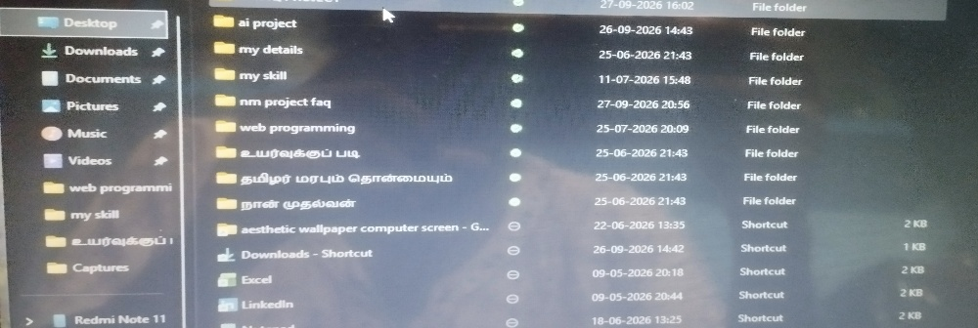
Project folder and src folder in VS Code
Figure 1: Initial AnswerBot project structure
INSERT SCREENSHOT HERE
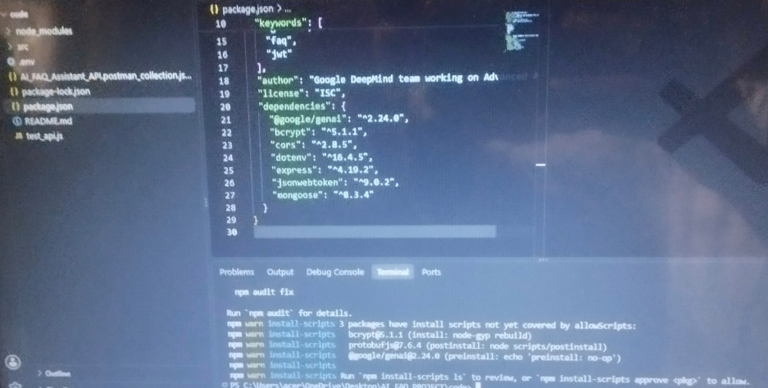
Node.js and npm version / installation
Figure 2: Node.jsand npm environment
INSERT SCREENSHOT HERE
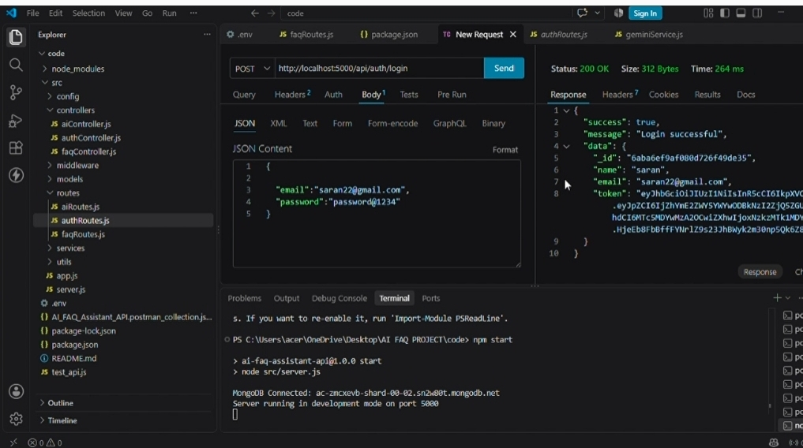
npm initialization and dependency installation
Figure 3: Project setup in VSCode terminal

Phase1 Output
Development environment prepared.
Project folder and src structure created.
Required backend dependency environment prepared.

PHASE 2 –SYSTEMARCHITECTURE AND DATABASE DESIGN
Objective: Design the layered backend architecture, define system components, establish the entity relationships, and prepare database schemas.

2.1 Project Architecture
The AnswerBot application exposes structured endpoints through a layered server architecture.
Incoming requestsundergo filter processing before interacting with data services.
Component | Definition
Interface | API tools such as Postman query route paths to extract JSON entities.
ExpressServer Gateway | Maps HTTP methods, parses JSON payloads, monitorsnetwork ports, and handlesCORS.
Authentication Middleware | Extracts tokens, validates user context signatures, and evaluates authorization thresholds.
Granular Services | Enforces isolated domain rules for sessions and query modifications.
Database Interface Layer | Mongoose translates application logic into MongoDBqueries.
AI Flow | Google Gemini SDK integration supports question-answering and automated topic generation.

INSERT SCREENSHOT HERE
System architecture diagram / architecture representation
Figure 4: AnswerBot layered architecture

2.2 Entity-Relationship Design
The backend database consists of MongoDB collections connected through logical references for authentication, FAQ management, AI-generated content, and category organization.
User Entity
_id –Primary Key (ObjectId)
name –String, Required email –String, Required, Unique password –String, Hashed, Required role –String, Default: user createdAt updatedAt
FAQEntity
_id –Primary Key (ObjectId) question –String, Required answer –String, Required category –String, Required createdBy –Foreign Key referencing User Collection createdAt updatedAt
AI Generation Entity (Logical) topic generatedQuestion generatedAnswer generatedCategory generatedAt
Category Entity (Logical) categoryName
description totalFAQs

2.3 Key Structural Mappings User → FAQ (One-to-Many)
Category → FAQ (One-to-Many)
User → AI Generated FAQ (One-to-Many)
FAQ → Search Results(Logical Relationship)
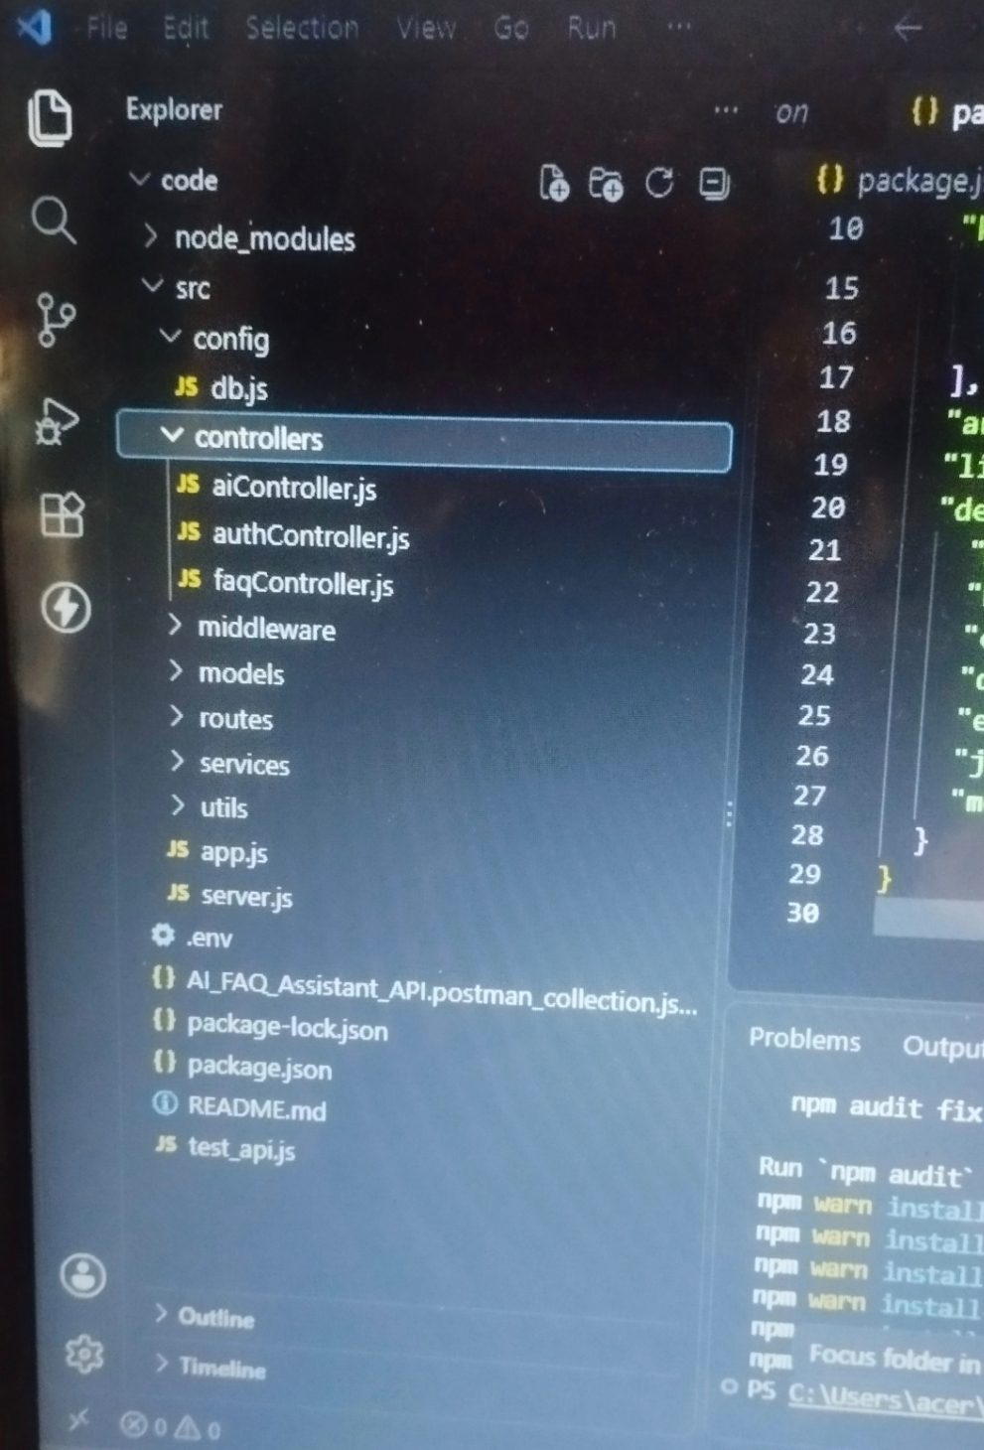
INSERT SCREENSHOT HERE
ER diagram / database relationship diagram
Figure 5: Entity-Relationship design
INSERT SCREENSHOT HERE
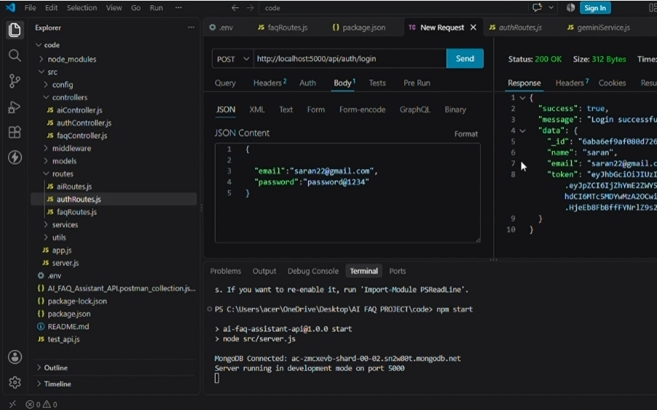
MongoDB collections / database view
Figure 6: MongoDB database and collection evidence

Phase2 Output
Layered architecture defined.
Database entitiesand fieldsidentified.
Logical relationshipsdocumented.
MongoDB data design prepared.

PHASE 3 –BACKEND DEVELOPMENT AND SECURITY
Objective: Implement the gateway server, Express application, authentication middleware, centralized error handling, models, and core backend logic.

3.1 Gateway Server –src/ server.js
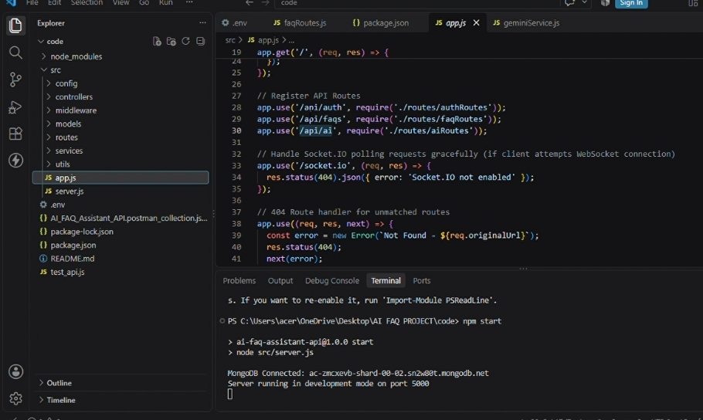
The main entrance mechanism aggregates environment variables, triggers database listeners, and bindsnetwork listenersto the active environment port.
INSERT SCREENSHOT HERE src/server.js source code
Figure 7: Gateway server implementation

3.2 Gateway ExpressSetup –src/ app.js
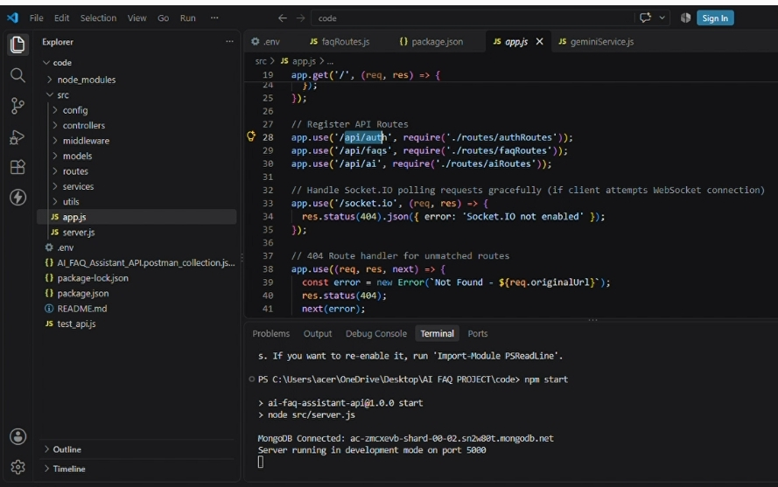
The Expressapplication formsthe backend gateway for request processing and API routing.
INSERT SCREENSHOT HERE src/app.js source code
Figure 8: Expressapplication setup

3.3 Security AccessMiddleware
The authentication middleware intercepts protected queries, extracts authorization header records, and validatestoken identity context claims.
INSERT SCREENSHOT HERE authMiddleware.js source code
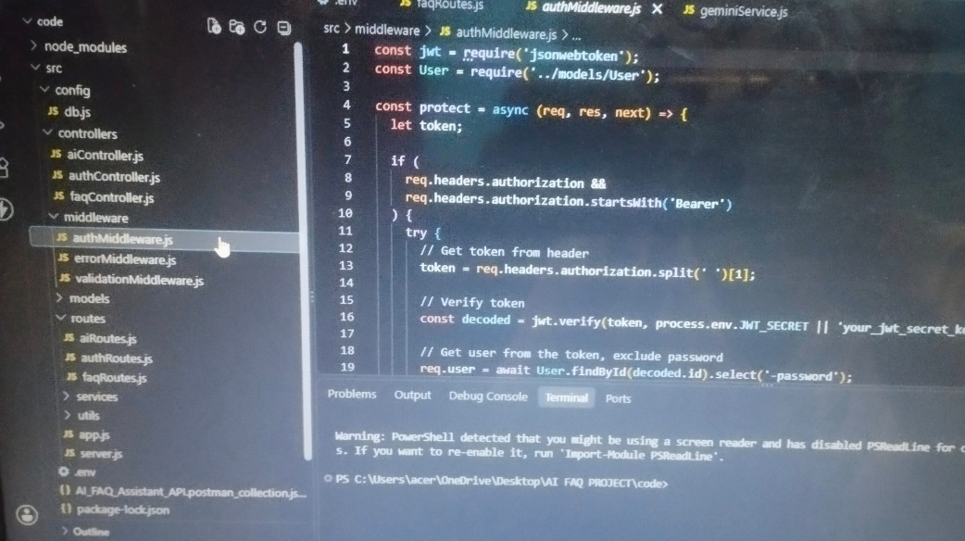
Figure 9: JWT authentication middleware

3.4 Centralized Error Handler Middleware
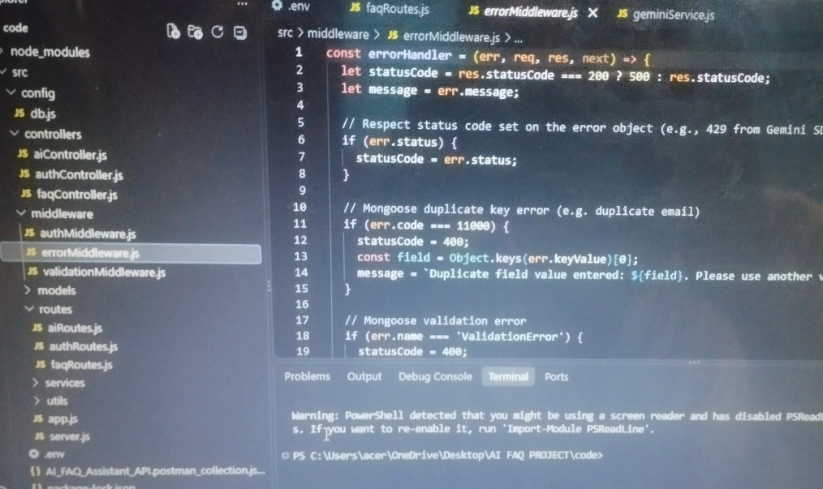
The centralized error handler provides standardized error processing and supports reliable API responses.
INSERT SCREENSHOT HERE errorMiddleware.js source code
Figure 10: Centralized error handler

3.5 User Model
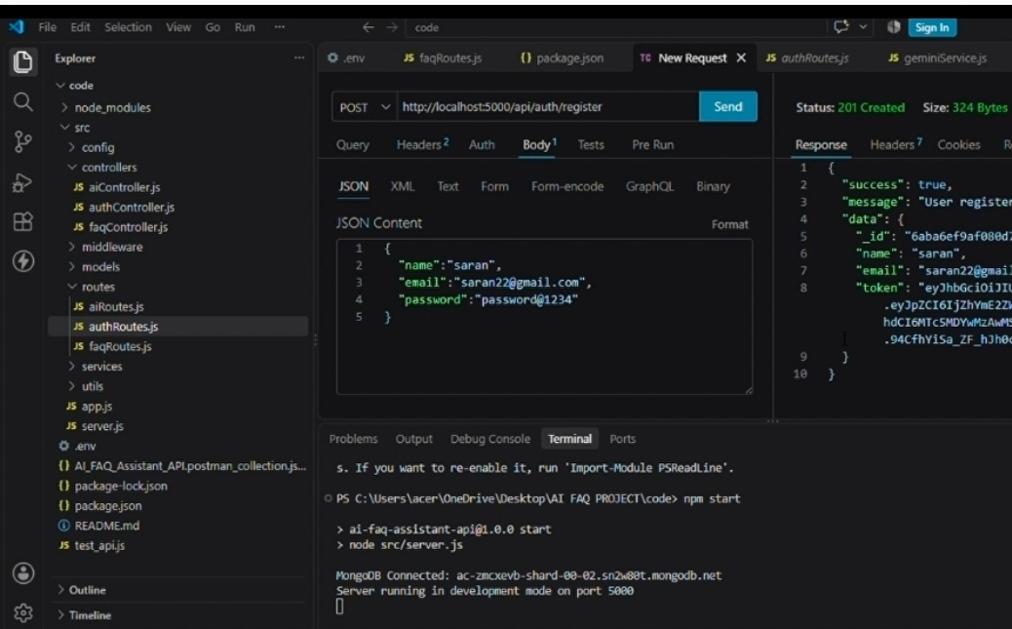
The User schema enforces profile field validation and supports password hashing before user document persistence.
INSERT SCREENSHOT HERE src/models/User.js
Figure 11: User Mongoose schema

3.6 FAQModel
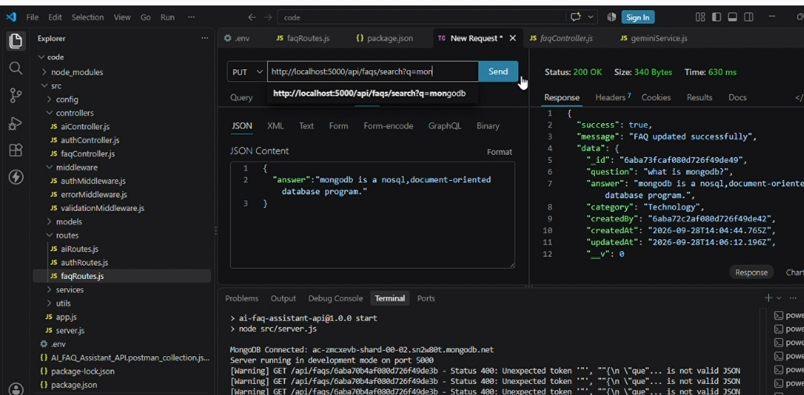
The FAQ model defines the question, answer, category, creator reference, and timestamp properties.
INSERT SCREENSHOT HERE src/models/FAQ.js
Figure 12: FAQ Mongoose schema

Phase3 Output
Expressbackend gateway implemented.
Authentication and authorization layer prepared.
Centralized error handling added.
Mongoose modelsdefined.

PHASE 4 –API ROUTESAND AI AUTOMATION
Objective: Connect the backend modules through API routes and implement authentication, FAQ operations, search, and AI-assisted FAQ generation.

4.1 Authentication Routes
Public authentication operationsare handled through src/ routes/ authRoutes.js.
Operation | Route | Access
Registration | POST /api/auth/register | Public
Login | POST /api/auth/login | Public
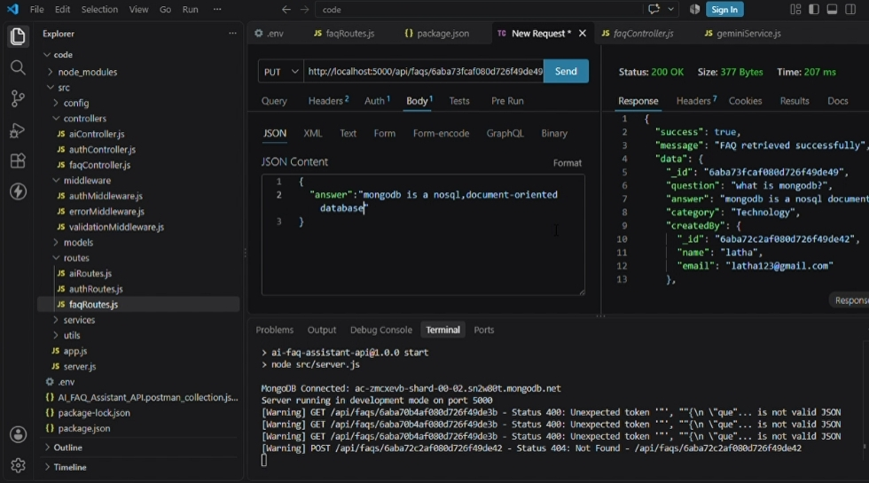
INSERT SCREENSHOT HERE authRoutes.js
Figure 13: Authentication route implementation

4.2 FAQRoutes
Protected FAQ operations are handled through src/routes/faqRoutes.js and use Bearer JWT authentication where required.
Operation | Route | Access
CreateFAQ | POST /api/faqs | Private –Bearer JWT Token
Search FAQ | GET /api/faqs/search?  q=configure | Public
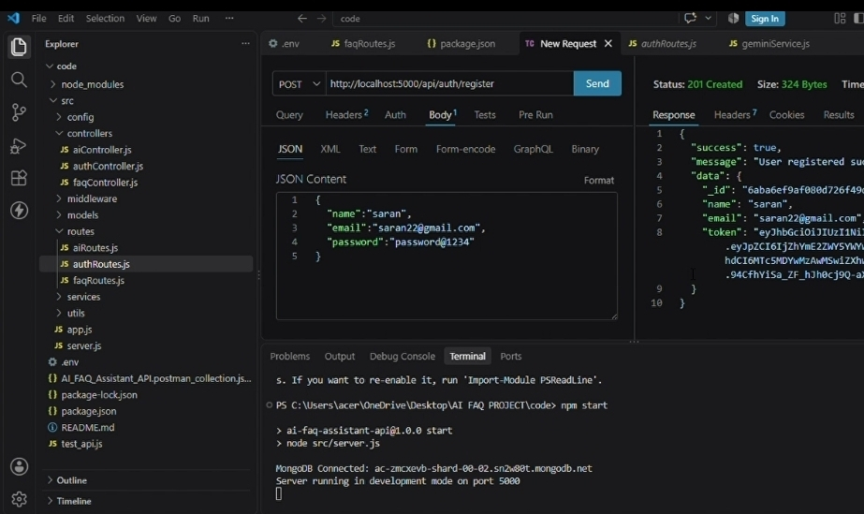
INSERT SCREENSHOT HERE faqRoutes.js
Figure 14: FAQ route implementation

4.3 AI Automation Routes
AI automation operations are handled through src/routes/aiRoutes.js. The reference specifies POST / api/ ai/ generate-faq asa protected operation.
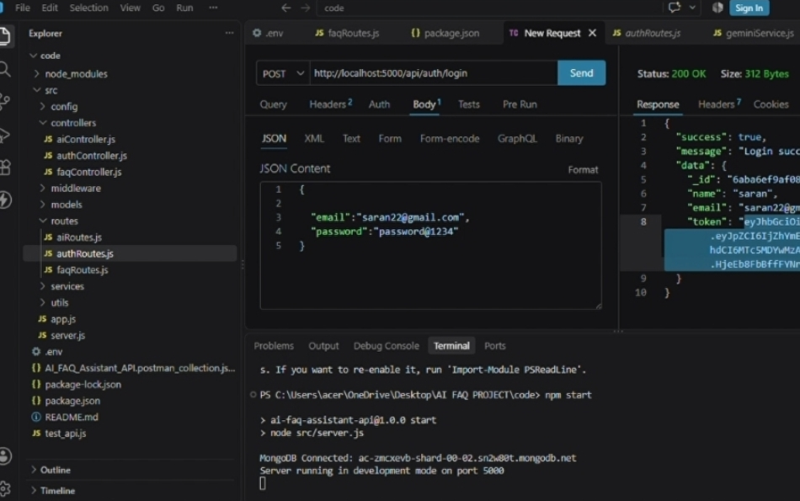
INSERT SCREENSHOT HERE aiRoutes.js
Figure 15: AI automation route implementation

4.4 AI FAQGeneration
Google Gemini AI automatically generates questions, answers, and topic suggestions. Generated content isrepresented through the logical AI Generation Entity before persistence.
INSERT SCREENSHOT HERE AI FAQ generation request and response
Figure 16: AI-generated FAQ result

4.5 API Testing
The project usesPostman or ThunderClient to verify API responsesand schema validation.

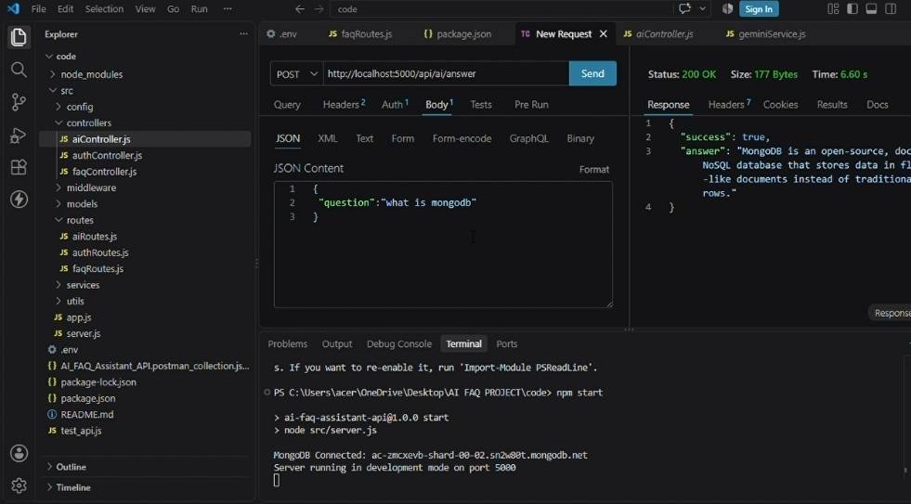
INSERT SCREENSHOT HERE Registration API in Postman / ThunderClient
Figure 17: Registration request andresponse
INSERT SCREENSHOT HERE
Login API and JWT response
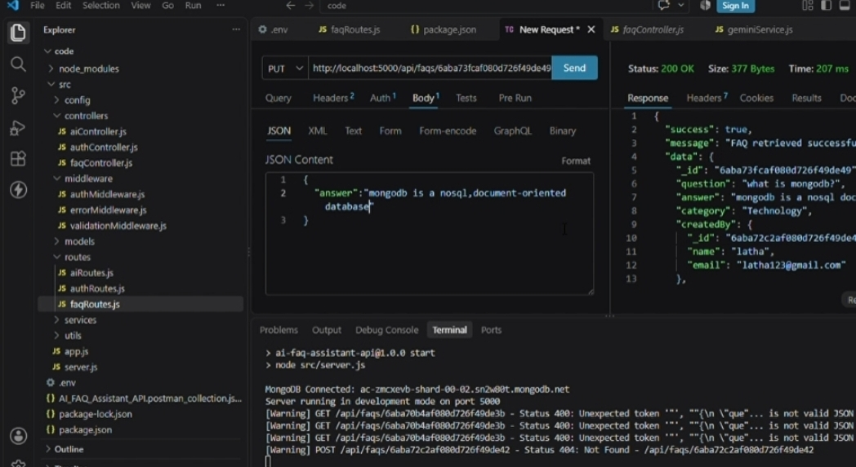
Figure 18: Login request and authentication token
INSERT SCREENSHOT HERE Create FAQ API
Figure 19: FAQ creation request and response
INSERT SCREENSHOT HERE FAQ search API
Figure 20: Keyword search request and response
INSERT SCREENSHOT HERE AI generate FAQ API
Figure 21: AI generation request and response

Phase4 Output
Authentication routesconnected.
FAQroutesconnected.
Search endpoint tested.
AI FAQ generation endpoint tested.
API responsesverified using Postman/ ThunderClient.

PHASE 5 – PROJECT EXECUTION, TESTING AND FINAL DEMONSTRATION
Objective: Run the complete backend application, verify the integrated workflow, document the final execution, and collect project evidence.

5.1 Running the Application
The reference document specifies starting the backend development server with the project's development command.
INSERT SCREENSHOT HERE Backend server running successfully
Figure 22: Running AnswerBot backend server

5.2 Complete Workflow Verification
- Start the backend development server.
- Verify database connectivity.
- Register a user through the public authentication route.
- Log in and obtain the authentication token.
- Use the token for protected FAQ operations.
- Create and manage FAQ recordsaccording to the authorization rules.
- Perform keyword-based FAQ search.
- Request AI-assisted FAQ generation.
- Verify the API response and generated content.
- Record the final successful project execution.
INSERT SCREENSHOT HERE
Complete project execution
Figure 23: Final project execution
INSERT SCREENSHOT HERE

MongoDB stored user / FAQ records
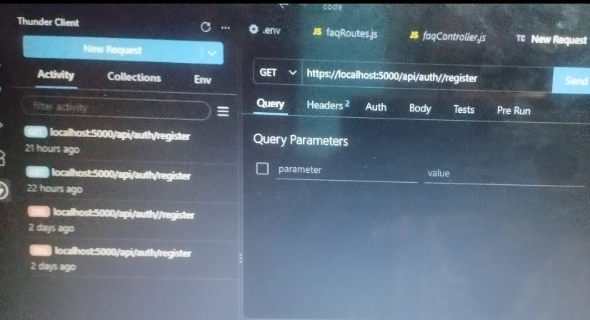
Figure 24: Database execution evidence
INSERT SCREENSHOT HERE
Complete Postman/ThunderClient collection
Figure 25: API testing evidence
INSERT SCREENSHOT HERE
Final project demo / application output
Figure 26: Final AnswerBot demonstration
5.3 Key FeaturesVerified JWT Authentication & Authorization
AI FAQGeneration
Semantic FAQSearch
Complete CRUDOperations
Category Management
Password Encryption using bcrypt
Centralized Error Handling
Schema Validation
RESTful API Architecture
MongoDB Integration using Mongoose ODM

5.4 Final Phase Output
Backend application executed successfully.
API endpointstested.
Authentication and protected routesverified.
FAQ operationsand search workflow verified.
AI-assisted FAQ generation demonstrated.
Project screenshotscollected asevidence.

5.5 Conclusion
AnswerBot provides a centralized backend platform for FAQ management and customer support automation. The phase-wise implementation combines Node.js and Express.js, MongoDB and Mongoose ODM, JWT and bcrypt security, and Google Gemini AI integration to support FAQ creation, authentication, search, and AI-assisted content workflows.

5.6 Future Enhancement
Extend AI-assisted FAQ generation workflows.
Improve semantic search and contextual query matching.
Add administrative monitoring capabilities.
Expand category and content management features.
Provide additional API analyticsand reporting capabilities.

